**Azure PowerShell**

The Azure Portal is where all of the Azure services are managed, but it's not the only place through which Azure resources can be managed. Another method is Windows Azure PowerShell.

It is a powerful scripting environment that you can use to control and automate the deployment and management of your workloads in Azure.

Azure PowerShell can be installed by two ways:

1. Using WebPI
2. Using Power Shell Gallery

**Installing Azure PowerShell using WebPI:**

Azure is controlled via a PowerShell module, which is provided by Microsoft. Your first task is to get this module installed. To do this, download and install the [Microsoft Web Platform Installer package](http://go.microsoft.com/fwlink/p/?linkid=320376&clcid=0x409) for the Azure module. This convenient installer will install the Azure PowerShell module and all of the prerequisites for you.

The installation will take just a few minutes. And once installed, you must then connect your Azure subscription.

**Installing Azure PowerShell using PowerShell Gallery:**

* Install the Azure Resource Manager modules from PowerShell Gallery

Install-Module AzureRM

Install-AzureRM

* Install the Azure Service Management module from PowerShell Gallery

Install-Module Azure

* Import AzureRM modules for the given version manifest in the AzureRM module

Import-AzureRM

* Import Azure Service Management module

Import-Module Azure

**More about these commands**

**Install-Module AzureRM** -> This installs a bootstrapping module for the AzureRM modules. This modules contains cmdlets to help update, uninstall and import the AzureRM modules in a safe and consistent way.

The AzureRM module contains a list of modules and the version range (min and max) required to ensure no breaking changes will be introduced for the major version of AzureRM

**Install-AzureRM** -> It installs all of the modules declared in the bootstrapping module.

**Install-ModuleAzure ->** Itinstalls the Azure module. This module is the Service Management module from Azure PowerShell 0.9.x. This should have no major changes and be interchangeable for the previous version of the Azure module.

**Import-AzureRM ->** Itimports all of the modules in the AzureRM module's list of modules and versions. This ensures that the Azure PowerShell modules that are loaded are within the version range required by the AzureRM module.

**Import-Module Azure** -> It imports the Azure Service Management module. Note, the Azure module and the AzureRM modules are loaded into your PowerShell session and can both be used together.

**Getting started with Azure PowerShell**

The module installs a customized console for Azure PowerShell. You can run the cmdlets from the standard Windows PowerShell console, or from the Azure PowerShell console. The method you use to open either console depends on the version of Windows you're running:

* On a computer running at least Windows 8 or Windows Server 2012, you can use the built-in Search. From the **Start** screen, begin typing power. This returns a scoped list of apps that includes Windows PowerShell and Azure PowerShell. To open the console, click either app. (To pin the app to the **Start** screen, right-click the icon.)
* On a computer running a version earlier than Windows 8 or Windows Server 2012, use the **Start menu**. From the **Start** menu, click **All Programs**, type **Azure Powershell**, and then click **Azure PowerShell**.

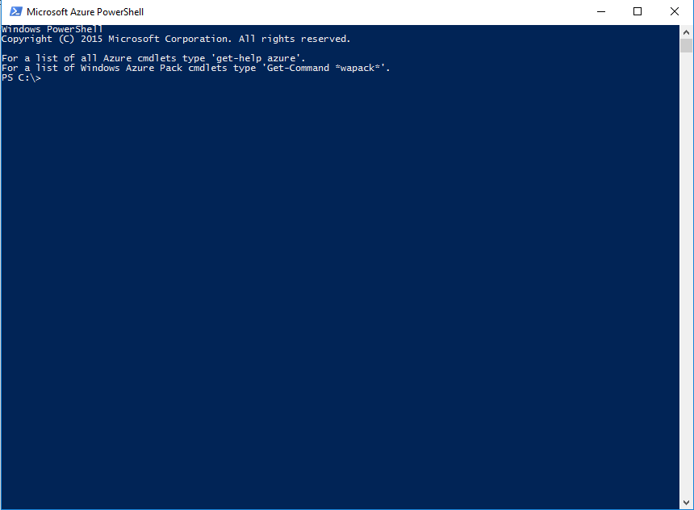

### **Commands to help you get started**

* To make sure the Azure PowerShell module is available after you install

Get-Module –ListAvailable

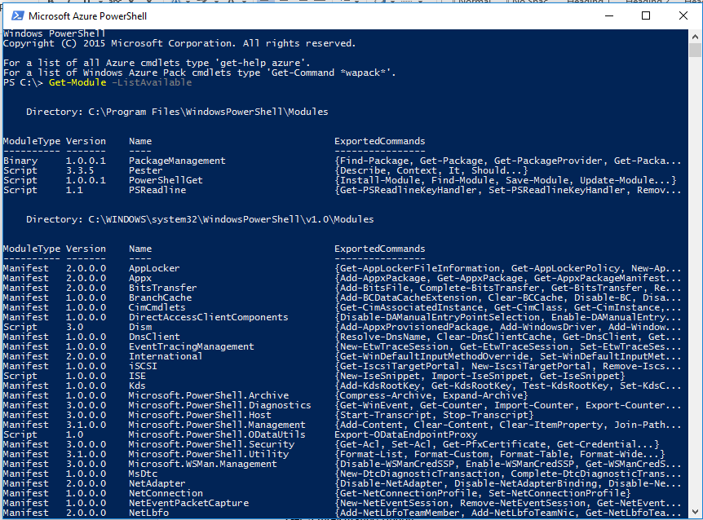

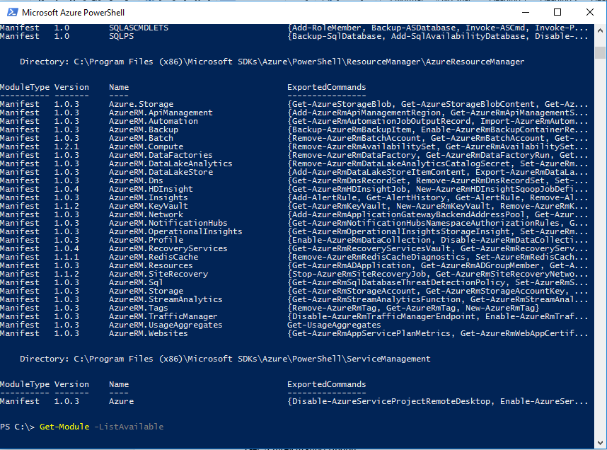

* If the Azure PowerShell module is not listed when you run Get-Module, you may need to import it

Import-Module Azure

* To login to Azure Resource Manager

Login-AzureRmAccount

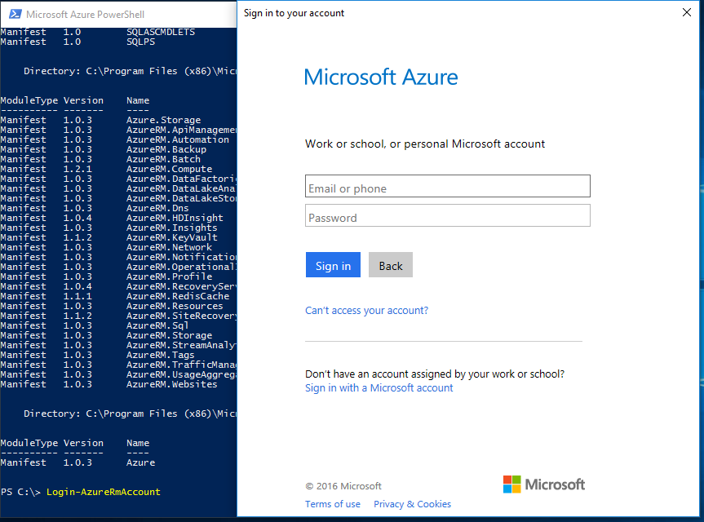

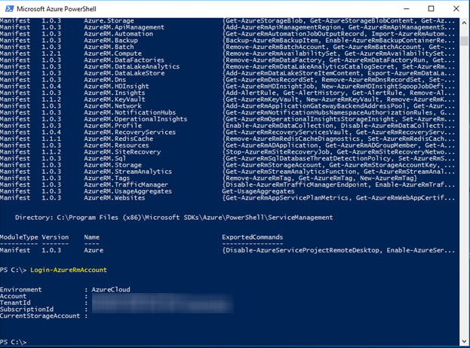

* You can also use a specific Tenant if you would like a faster login experience

Login-AzureRmAccount -TenantId xxxx

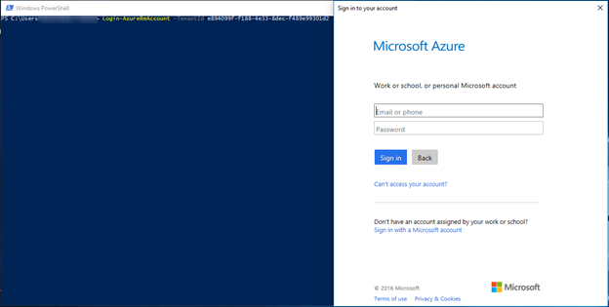

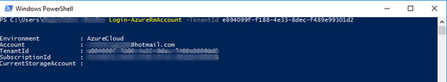

* To view all subscriptions for your account

Get-AzureRmSubscription

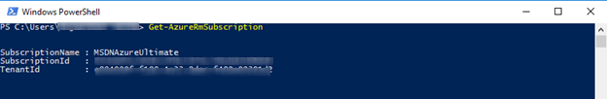

* To select a default subscription for your current session

Get-AzureRmSubscription –SubscriptionName “your sub” | Select-AzureRmSubscription

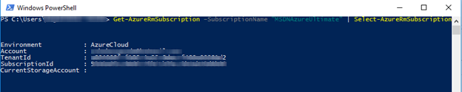

* View your current Azure PowerShell session context

This session state is only applicable to the current session and will not affect other sessions

Get-AzureRmContext

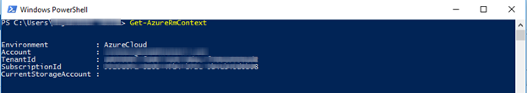

* To select the default storage context for your current session

Set-AzureRmCurrentStorageAccount –ResourceGroupName “your resource group” –StorageAccountName “your storage account name”

* View your current Azure PowerShell session context

Note: the CurrentStorageAccount is now set in your session context

Get-AzureRmContext

* To import the Azure.Storage data plane module (blob, queue, table)

Import-Module Azure.Storage

* To list all of the blobs in all of your containers in all of your accounts

Get-AzureRmStorageAccount | Get-AzureStorageContainer | Get-AzureStorageBlob

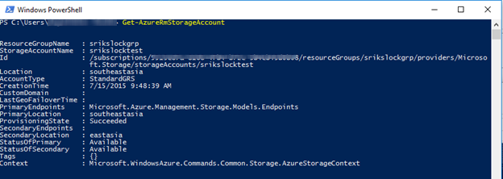

Currently I don’t any storage container, So it is blank.

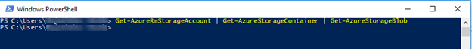

**Connecting to the Azure portal using PowerShell**

1. Type **Login-AzureRmAccount**
2. Type the email address and password associated with your account. Azure authenticates and saves the credential information, and then closes the window.

OR

This below scripts avoid pop up

$cred = Get-Credential

Login-AzureRmAccount -Credential $cred

### **View account and subscription details**

You can have multiple accounts and subscriptions available for use by Azure PowerShell. You can add multiple accounts by running **Add-AzureRmAccount** more than once.

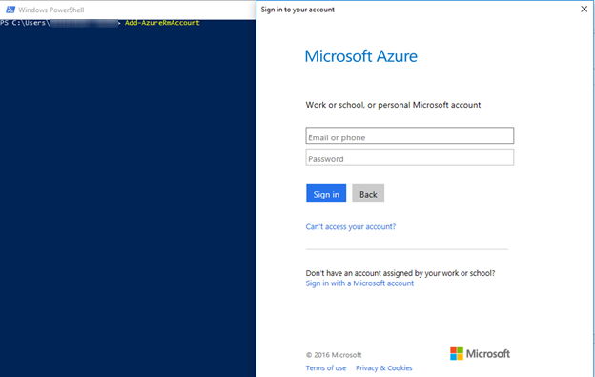

To display the available Azure accounts, type **Get-AzureAccount**.

To display your Azure subscriptions, type **Get-AzureRmSubscription**.

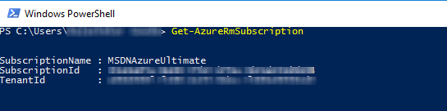

*END OF THE DOCUMENT*